Group 7 – Double Stacked Container Train – Problem Description

A double stack container train is a means of transport for containers typically originating from a port or other large transport hub. A double stack container train usually consists of one or two locomotive which provide the power for the train. The rest of the train consists of wagons which can accommodate two forty foot container units stacked on top of each other or a combination of four twenty foot container units. These trains have the main mission of transporting a large amount of containers on one train as shown in figure 1. The train must also maneuver itself in railyards for loading and unloading of containers. To complete these missions it has the following operational tasks:

* Needs to transport cargo at desired speed and power
* Needs to be stable
* Wagons needs to be coupled and decoupled easily

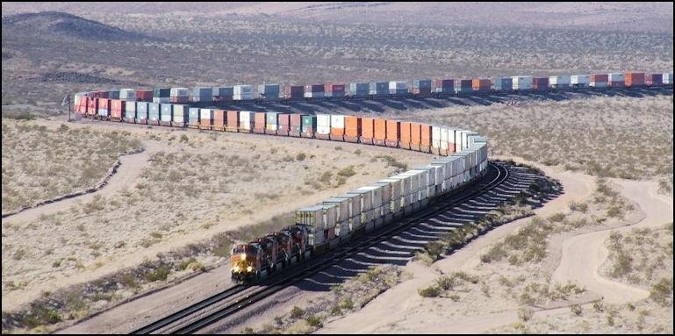

Figure 1 Double stacked container on a fixed rail route[1]

Afbeelding met voertuig, Schaalmodel, trein, Landvoertuig

Door AI gegenereerde inhoud is mogelijk onjuist.

Figure 2 Container loading in Port of Baltimore[2]

The motivation to make the double stack container train more intelligent is driven by the need to improve efficiency, safety, and autonomy in freight transport operations. Currently, many of the actions such as driving, coupling/decoupling, and positioning for loading and unloading rely on human input, which introduces delays, higher labor costs, and potential for human error. Intelligent operation would allow the system to:

* Drive autonomously, reducing dependence on human drivers who are constrained by labor laws and fatigue, and improving overall operational efficiency.
* Synchronize its position with cranes or other infrastructure for autonomous loading/unloading, minimizing idle time and increasing terminal throughput.
* Continuously monitor and adjust for stability, e.g., when transporting double-stacked containers at higher speeds or over uneven tracks, thereby enhancing transport safety.

Since a train drives on tracks and switches are often operated remotely, the main control objective of driving a train autonomously is reaching and maintaining a desired speed, i.e. the maximum speed on that part of track or the maximum safe speed to operate the train.

When loading and unloading autonomously, speed is not the control objective, but a constraint. The control objective is the position the train needs to have to line up with a crane, a maximum speed on that part of track would be a constraint in how fast the train can move to obtain the control objective.

The control objective for stabilization would be to try to minimize angle accelerations to make sure the containers stay in their place when experiencing disturbances in the track or to compensate for forces in corners. This could for instance be done with a gyrostabilizer. The main control variables are:

1. Vref to reach a desired speed for autonomous driving
2. Xref to reach a specific location (along the rails) for loading and unloading
3. For autonomous stabilator of the containers during transport: to minimize angle accelerations at the wagon

The velocity and position can be determined via the following measurement variables:

1. Psensor(k) – measures the power P of the locomotive motor
2. v(k) - measures the velocity of the train at the wheels
3. xpos(k) - measures the GPS x-position of the train
4. ypos(k) - measures the GPS y-position of the train

To control the system, the following action can be done:

1. u(k) = P(k) – change the motor power (a negative motor power means *braking*)[3]

1. Odeleye, Joshua. (2015). The need for multimodal transport development in Nigeria. Journal of Geography and Regional Planning. 8. 239-243. 10.5897/JGRP2015.0508.
2. Kalmbach Media. (n.d.). *Container loading in Port of Baltimore* [Photograph]. Trains. <https://www.trains.com/trn/news-reviews/news-wire/csx-launches-double-stack-service-at-the-port-of-baltimore/>
3. Transportation Safety Board of Canada. (2022, March 31). *TSB key facts for occurrence R19C0015 – Uncontrolled movement and main-track derailment*. <https://www.tsb.gc.ca/eng/medias-media/fiches-facts/R19C0015/r19c0015-20220331-3.html>